Let us define an arbitrary expression in EQN: e^(X^3) – X + 1

Enter it into the EQN editor, by:  - f EQN: [NEW] [F1] [F2] [F3] g[3] [F6] g[-] [F2] g[+] g[1] ENTER  - or [NEW] e^{x} x ^ 3 [→] - x + 1 ENTER  - Press 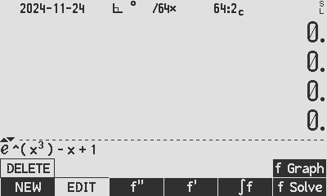 to directly access the graphing feature: | 
Enter reasonable x-limits for the calculation of the graph; let us choose x from -1 to 1 and enter these as the x-extents into Y and X registers. Use the [x*] to enter any graph value – it is better to get used to it before you forget to set the variable *:  - 1 [CHS] [x*]  - 1 [x*]  [x*] indicates the variable of the expression that will be ramped from Y to X. For a single variable, like here, the star is populated automatically, but for multiple variables, the value entered for the last one always gets the star re-allocated to them. Make sure the star is on the actual ‘x’ variable.  Press 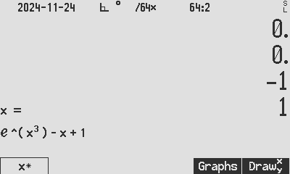 to “draw from the Y-register to the X-register”. The  indicates that this draw command does not use stored limits, it uses the registers. | 
The graph auto-scales to fit the x-scale entered, and auto-scales the y-scale to a reasonable automatically determined range.  The information part 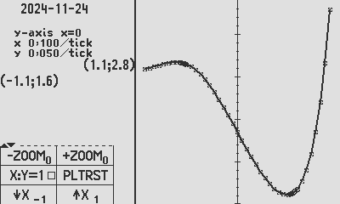 represents the coordinate of the lower left corner of the cartesian plane, and the top right corner. The scales of the axis are indicated here, and are not the same in X and Y by default. This is to be able to view a better portion of the initial graph. The information part  means the following: “The ‘y-axis is visible and at coordinate x=0”. And “The ticks visible on the y-axis represent 0.05 per tick and the x axis has 0.1 per tick”. The x-axis is not visible due to the auto-scaling.  Press the  button twice to get to Zoom level -2, and now the scale has changed to 0.5 per tick and the x-axis is visible. Now the axis details has changed, showing ‘the axes are at x=0 & y=0, and y has changed from 0.05 per tick to 0.5 per tick, literally a 10-fold zoom out. 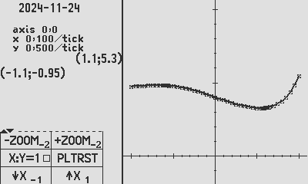.  Experiment with the  control, see on the right, the point of this control is to force the axis parameters the same, as if you had classical graph paper. Again you can use ZOOM.  The reason that the graph appears shorter on the x-axis now, is that you zoomed out and then forced symmetry on the axes, while the numerical calculation stayed the same, i.e. 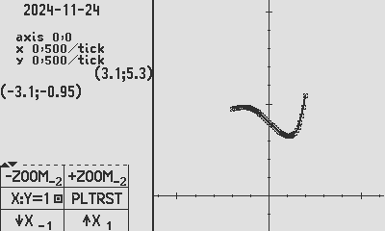 meaning the x-range for calculating remains as per F1 & F2, from -1 to +1 as was determined in the beginning.  Before we conclude p1, press  (Plot Reset) to reset the various parameters, zooms, etc.  NOTE: During all operations, the database for the points has NOT been re-calculated. |   Standard, automatic rendering    A smaller graph visible after zooming out -2    Graph on 1:1 cartesian plane, after X:Y=1
Now we are ready to go to p2 of the menu: Press the [↑] button to go to p2: The commands here:  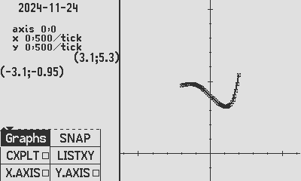 goes to the graph input menu; you can also just press a number to change the x-range, and the Graphs menu will open.   is located here for convenience, however, the g[EXIT] snap remains in operation, also the f+[DISP] remains in operation.   plots a complex result onto the real (x) axis and imag (y) axis. This cannot be demonstrate now as the formula printed can only produce real output. See Appnote 11a for an example.   assists by listing the graph coordinates. This function is likely sunsetting.   These buttons help to influence the auto-scaling to bring the axis into the picture. In this example on the right, the x-axis is off screen. This can easily be seen by noticing in the coordinates 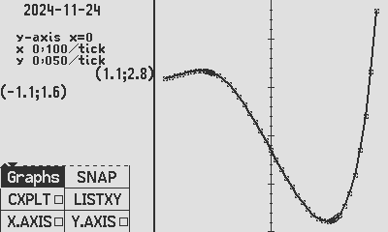 that Y range from 1.6 to 2.8, that is clear that the x-axis cannot be visible. This is where you select  to produce the picture on the right, with the x-axis visible. |   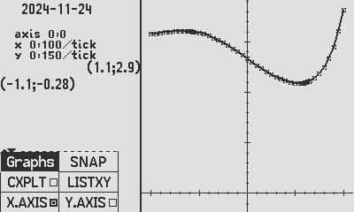  x-axis in view after pressing X.AXIS
Now we are ready to go to p3 of the menu: Press the [↑] button to go to p3: The commands here:  P3 simply control the graphic – do experiment and change the points and line | 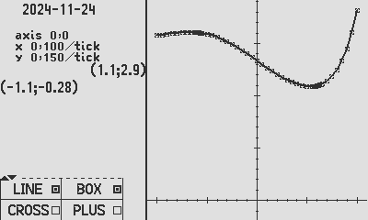
Press the [↑] button to go to p4: The commands on p4 will not be demonstrated here. Briefly,  N.VECT and VECT will draw each coordinate pair as a vector with a direction arrow. N.VECT arranges the axis to be a compass plane, with North being the Y-axis and the rotation opposite to the mathematical cartesian plane.  F1 and F2 calculates graphical trapezoid sum from the graph, and does a rate-of-change graph, aka. Numerical differential graph. RMS Calculates a root-mean-square average of the graph, from left, accumulating to right. | 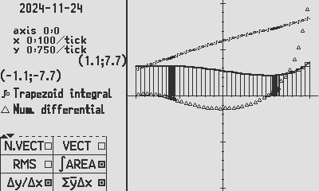
Change the x-range by entering different limits into  by directly pressing a number to go to the Graph menu, press the Graph Menu button or pressing F1 or F2.  Press 2 to go to the Graphs menu, [CHS] changes sign,  Press F1 to enter the left limit.  Press 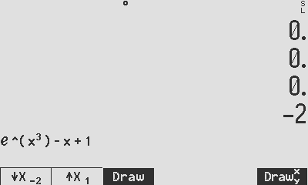  2 [CHS] [F1] 0.8 [F2] [F3]  Note: draws to the stored  parameters while  draws using the x-range from the stack, Y to X. | 

Author Jaco Mostert
Copyright (C) 2024 The C47 Development Team. Permission is granted to copy, distribute and/or modify this document under the terms of the GNU Free Documentation License, Version 1.3 or any later version published by the Free Software Foundation; with no Invariant Sections, no Front-Cover Texts, and no Back-Cover Texts. A copy of the license can be downloaded from gnu.org.

